# Submitting Roster Verification & Final Grades

## What Is the “MY COTC” Block?

All COTC courses in Moodle should have a menu block entitled “MY COTC.” Use the MY COTC block to submit Roster Verification and Final Grades quickly and easily from your Moodle courses. If you do not see this block, please refer to the Adding a MY COTC Block instructions at the end of this document.

## Submitting Roster Verification

Roster Verification is *required* for all courses. Please refer to the email you received from Academic Affairs and/or Student Records for exact deadlines for submitting Roster Verification. Follow these steps to submit Roster Verification:

1. Locate the **MY COTC** block in the lower right-hand corner of your **Course Home** page and click the **Roster Verification** link.

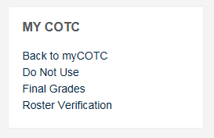

1. Moodle will redirect you to a page showing the roster of students currently enrolled in your class. Enter the last date of attendance for each student using MM/DD/YYYY format (you must include the slashes).

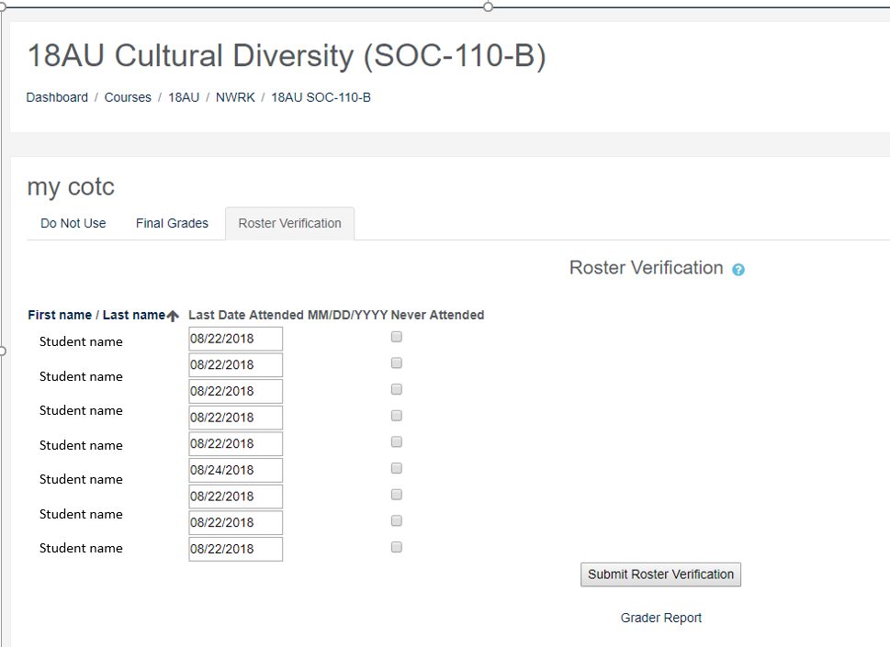

# Submitting Roster Verification & Final Grades

1. For any students who have never attended, leave the **Last Date Attended** field blank, and select the **Never Attended** checkbox.



1. Click the **Submit Roster Verification** button to submit the information to our student information system (Colleague).



1. A message will display at the top of the page to indicate any errors or if your attendance verification submitted successfully. If your submission was not successful, please contact Veronica Rine ([rine.60@cotc.edu](mailto:rine.60@cotc.edu) or 740-755-7600) for assistance.

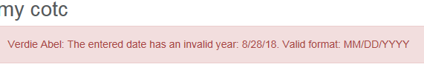



*\*WARNING: For merged course sections in Moodle, you must go back to each of the original course sections to submit Roster Verification. Each student must have verification submitted from the original section of enrollment.*

# Submitting Roster Verification & Final Grades

## Submitting Final Grades

***Final Grades are* *required.***Assign a final grade to *every* student on your class roster, regardless of whether or not the student attended class. Record and submit all final grades through the MY COTC block in Moodle.

Please refer to [Grade Information](http://www.cotc.edu/Academics/Pages/Faculty-Teaching-Resources.aspx#Final%20Grade%20Submission) on the COTC website for additional information about the final grade policies. Refer to the [COTC Academic Calendar](http://www.cotc.edu/Academics/Pages/Academic-Calendar.aspx) for exact deadlines to submit students’ grades. Note that the deadline for submitting graduating students’ grades is different from the deadline for submitting non-graduating students’ grades.

Follow these steps to submit Final Grades:

1. Locate the **MY COTC** block in the lower right-hand corner of your **Course Home** page) and click the **Final Grades** link.

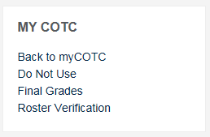

1. The students’ cumulative grades from Moodle Gradebook will appear in the **Current Grade** column. Use the **Populate final grade** drop-down to transfer students’ final grades from the Moodle Gradebook to the **Final Grade** column or simply type the students’ final grade in the **Final Grade** column. To prevent submission errors, please be sure to use only the official [COTC Grade System Codes](http://www.cotc.edu/Academics/Pages/Faculty-Teaching-Resources.aspx#Final%20Grade%20Submission). *\*NOTE: If you have graduating students and are required to submit their grades early,* ***DO NOT*** *select the* ***Populate final grade*** *drop-down! Instead, manually enter the final grades for ONLY the graduating students in the* ***Final Grade*** *column, and then click* ***Submit****.*

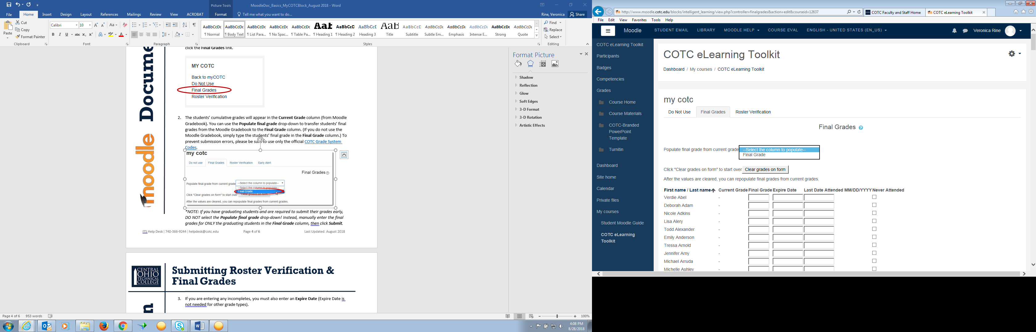

# Submitting Roster Verification & Final Grades

1. If you are entering any incomplete grades, you must enter the alternate grade the student will receive if they do not complete the agreed upon work. You must also enter an **Expire Date** (Expire Date is not needed for other grade types). Check the Academic Calendar for appropriate expire dates.



1. Enter the last date the student attended your course in the **Last Date Attended** column, and check the **Never Attended** checkbox for any students who never attended your class, then click **Submit Grades** to complete the final grades process.

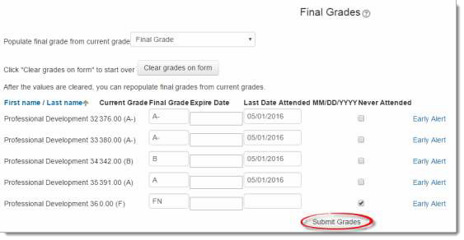

1. If you need to update or modify a Final Grade that you have already submitted, you can repeat steps 1 – 4 to update the grade(s) via the MY COTC Block in Moodle. However, you may re-submit changes/updates to Final Grades only until the cutoff date listed in the [COTC Academic Calendar.](http://www.cotc.edu/Academics/Pages/Academic-Calendar.aspx) After this date, you must submit a Grade Change Form.

*\*WARNING: For merged course sections in Moodle, you must go back to each of the original course sections to submit students’ final grades. Each student must have final grades submitted from the original section of enrollment.*

# Submitting Roster Verification & Final Grades

## 

## Adding a MY COTC Block

By default, all new courses should have a MY COTC Block, located in the lower right-hand corner of the Course Home page. If for some reason you do not have the MY COTC Block on your Course Home page (e.g., course copied an older course or Faculty Shell, accidentally deleted the block, etc.) follow the instructions below to add it:

1. Click the Action Gear in the right hand corner of the **Course Home** page. Select **Turn editing on**.
2. Open the slide out menu by clicking the Three-Line menu button in the top left hand corner of Moodle. At the bottom of that menu, locate the **Add a Block** option.

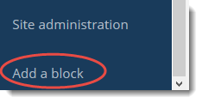

1. Click the **Add a block** link and select the **my cotc** option.

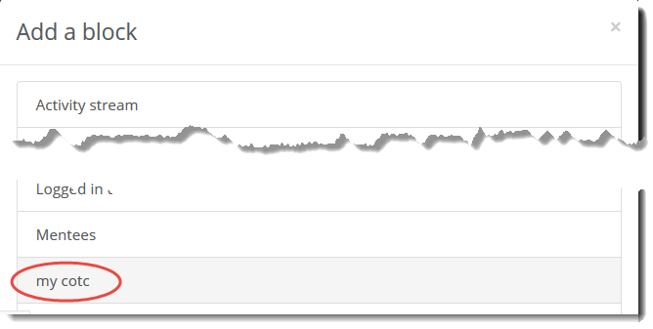

1. The MY COTC Block will appear in the default location in lower right hand side of the **Course Home** page. Click and hold down on the move icon  to drag the block if you wish it in a different location.